European Cooperation Day 2012
Sharing borders – Growing closer

What is European Cooperation Day?
European Cooperation Day is a pilot initiative with a focus on promoting European Territorial Cooperation (ETC) to the general public and media.
On this day, a broad range of local events will take place all over Europe, highlighting the importance of territorial cooperation. By sharing one concept, one brand and one visual identity, these diverse actions will be unified under the image of European Cooperation Day.
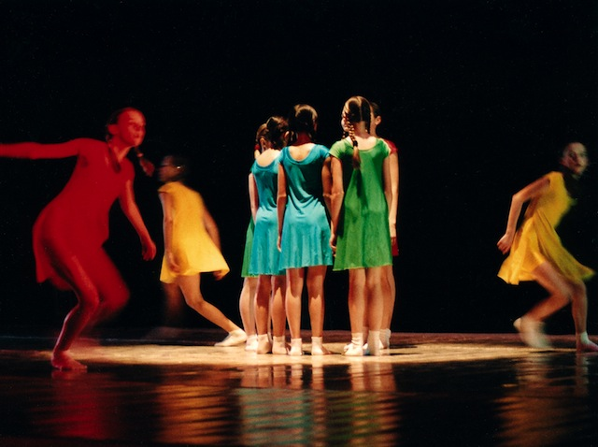
When is it?
21 September 2012 is European Cooperation Day. But events can take place any time during the week of 17-23 September and beyond.
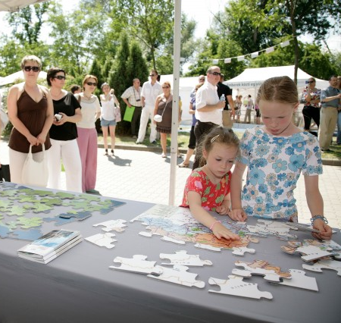
Who will take part?
Every ETC, IPA CBC and ENPI CBC programme and project is encouraged to join European Cooperation Day. Participation is of course voluntary, but the more programmes and projects that participate, the more successful European Cooperation Day will be. So far, over 65 programmes are onboard!

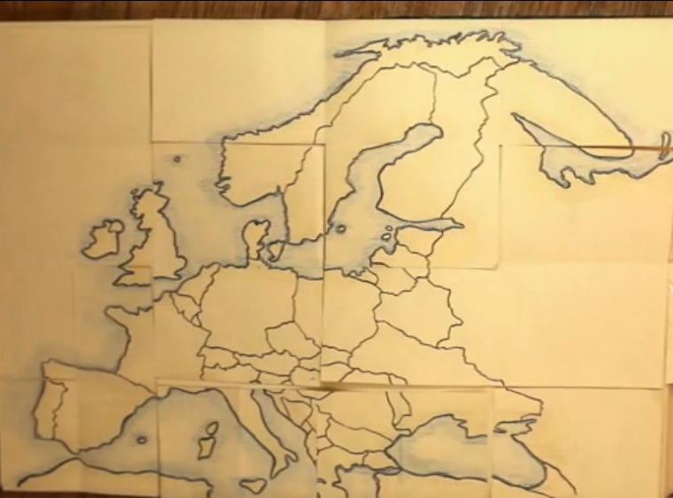
Where will it take place?

In cross-border and transnational areas across Europe and in neighboring regions. Find events across Europe on the interactive map: www.europeancooperationday.eu
How can we get involved, as a project?
- Get connected!
Visit www.europeancooperationday.eu and find out about all events and actions taking place across Europe.
Join European Cooperation Day’s community on Facebook and follow on Twitter.
- Promote!
Bring European Cooperation Day to the forefront by promoting it during your events, on your website, in your publications, through your social media platforms and press relations.

These tools will help you to promote European Cooperation Day:
    - European Cooperation Day website www.ecday.eu
    - European Cooperation Day flyer (short+long version), available on the website
    - European Cooperation Day logo, available on the website
    - European Cooperation Day on Facebook and Twitter
    - European Cooperation Day promotional video in English, French and German on YouTube

- Participate!
If you plan an information activity targeting the general public in the week of 17.-23.9.2012, why not participate in European Cooperation Day?
Participation is very easy - by distributing information materials, mentioning the European Cooperation Day in articles, speeches or interviews and/or showing the logo on slides, billboards, invitations etc. Please contact the HURO programme for further information and support!
Contact
For any questions related to European Cooperation Day 2012 (eg promotion and participation related costs), please contact the HURO PROGRAMME [abogdan@huro-cbc.eu].

Who is coordinating European Cooperation Day?
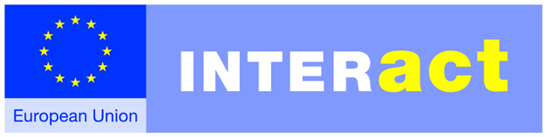
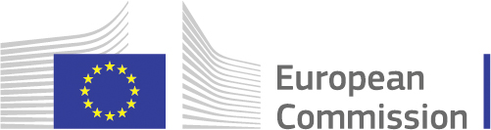
INTERACT is a Europe-wide cooperation programme that provides technical support to ETC programmes. INTERACT also promotes European Territorial Cooperation and its results; this is why they, with the support of the European Commission, are coordinating European Cooperation Day.

www.interact-eu.net ec.europa.eu/regional_policy

